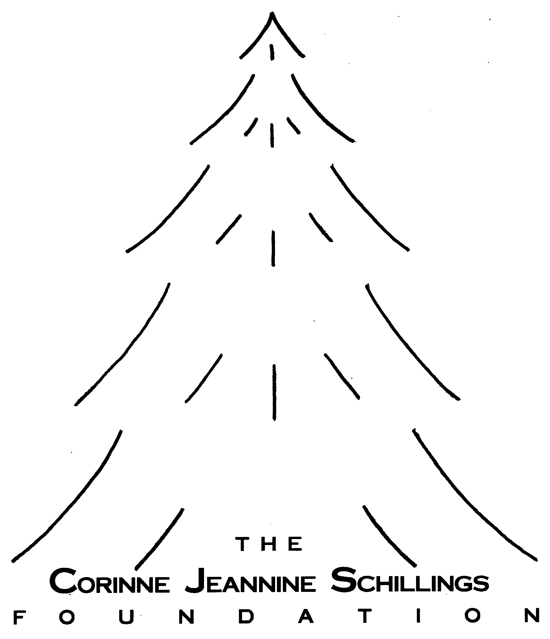
Scholarship to Study Abroad Application
2nd Semester

(Use this application if you will be studying abroad for the second semester.)

Applications MUST ARRIVE no later than 5:00pm CST, on the deadline date!
Applications WILL NOT be accepted prior to October 15
Application and all support materials should be shipped in ONE package.

Personal Information

Full Name __________________________________________________________________
Permanent Address __________________________________________________________
__________________________________________________________
Telephone # _______________________ Cell phone # ______________________
Email Address _________________________________ Date of Birth _____________________
(Correspondence concerning this application will be through email.)

Girl Scout Information
I received the □ Silver Award on __________ □ Gold Award on __________

Name of Local GSUSA Council __________________________________________________
Council Address ______________________________________________________________
_____________________________________________________________
Council Telephone # ___________________
Name of Local Council’s E.D./C.E.O. ______________________________________________
*NOTE
*You MUST provide proof verifying your receipt of the Silver or Gold Award.
*You MUST submit a letter of recommendation from a Girl Scout volunteer or staff member who is not a relative.
*The letter of recommendation MUST be written within the past six months, specifically for this scholarship.

Educational Background

THIS YEAR I am a college: Sophomore Junior Senior (circle one)

I am attending:
Name of University/College ______________________________________________________
Address: _____________________________________________________________________
_____________________________________________________________________
My major is: ________________________________________________________
My minor is: ________________________________________________________
My current grade point average is: ________
*You MUST include a copy of your transcript.
*You MUST provide proof that you are a full-time student in good standing, progressing toward a degree.

What language do you speak (other than English)? _____________________________
Where will you be studying abroad?
Name of University/College ______________________________________________
Address: _____________________________________________________________
______________________________________________________________
What will be your course of study? _____________________________________________________________
When will your study abroad begin? ___________________ End? ________________
*You MUST provide proof that you have been accepted to study at the foreign
university/college, through an accredited university/college/program in the United States.

___________________________________________ ____________________
Signature of Applicant Date

___________________________________________ ____________________
Signature of Parent/Guardian Date
___________________________________________
Printed Name of Parent/Guardian
____________________________________________________________________________
Address of Parent/Guardian
__________________________
Telephone # of Parent/Guardian

Essay

We want to know about you, your past, your present, and your dreams for the future. In an essay, not to exceed 5 pages (MUST be typed, 12 pt. type, double spaced, 1-inch margins, numbered pages), answer the following: (Note: questions 2, 3, & 4 are DIFFERENT from those in the Academic Scholarship.)

- Who are you? (You MUST include, but are not limited to your interests; experiences that have
shaped who you are; impact of Girl Scouting on your life; activities outside of Girl Scouting.)
- Why have you chosen to study abroad? What do you hope to get from the experience?
- Why have you chosen your major and minor?
- Why do you feel you should receive support from the Corinne Jeannine Schillings Foundation
to study in the country you have chosen?

Applications MUST ARRIVE no later than 5:00pm CST, on the deadline date!
Applications WILL NOT be accepted prior to October 15.
Application and all support materials should be shipped in ONE package

[Applications arriving after the deadline, for any reason, WILL NOT be considered!]
Due Dates
Friday, December 2, 2022 (5:00 pm, CST)
Friday, December 1, 2023 (5:00 pm, CST)
Friday, December 6, 2024 (5:00 pm, CST)
Friday, December 5, 2025 (5:00 pm, CST)
Friday, December 4, 2026 (5:00 pm, CST)

(NO fax or electronic applications will be accepted.)

Applications must be sent directly to the foundation at:
Corinne Jeannine Schillings Foundation
10645 Nebraska St.
Frankfort, Illinois 60423-2223
*******************
Contact Information: www.cjsfoundation.org
dschillings1@comcast.net
815-534-5598 or 630-886-0507

